Software Package - Winder

Software Package - Winder

Open and closed-loop technology required for winder applications was previously usually contained in the higher-level PLC. Intelligent drive controllers are now able to take over these functions.

The advantages:
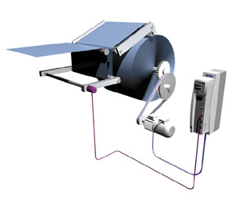

Relieves the load on the higher-level PLC and the bus systems
Commissioning is quick and easy thanks to standard solutions
Drive-based functions are integrated directly in the drive

Areas of application

The "Winder" software package provides solutions for centre winding machines with dancer control or tensile control (open-loop or closed-loop).

Areas of application
The "Winder" software package provides solutions for centre winding machines with dancer control or tensile control (open-loop or closed-loop).

Areas of application:
Cables, wires, textiles, paper, sheet steel, metal strip, thin metal foil
Features - Open-loop/closed-loop tension control
- Internal diameter calculation
- Traction configured via ramp generator
- Open-loop tension control via characteristic curve function
- Automatic identification of the current mass moment of inertia and friction
- Acceleration torque and friction compensation
- Calculation of material density with landing computer
Features - Dancer position control
- Diameter calculated internally with dancing roller motion compensation
- Teaching of dancing roller end positions
- Tensile force controlled via characteristic curve function using dancing roller
- Automatic identification of the current mass moment of inertia
- Acceleration torque compensation
- Calculation of material density with landing computer

